UID: 504958165

Name: Kanisha Shah

1. Linear Regression

Part a)

**Closed-Form Solution:**

Since, Beta is initialized to 0, Beta, Training MSE, and Test MSE has the same value for each execution.

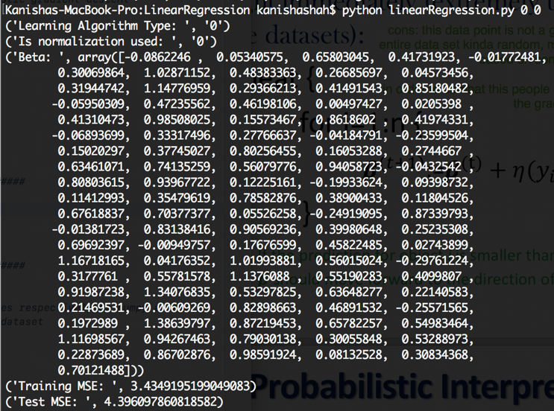

**Batch Gradient Descent:**

Since, Beta is initialized randomly, Beta, Training MSE, and Test MSE has different values during each execution.

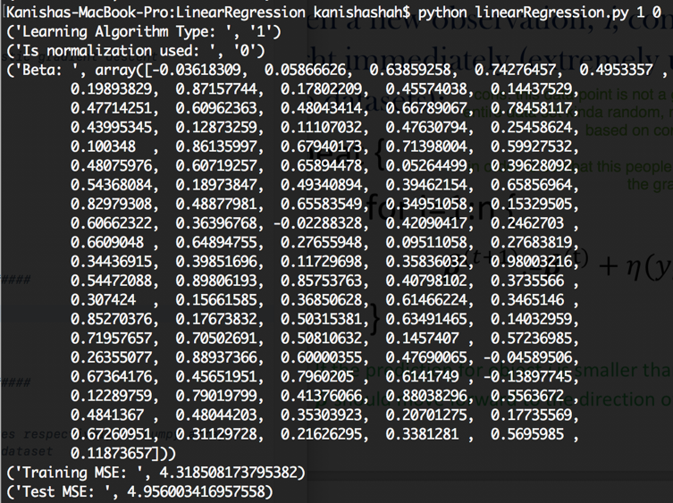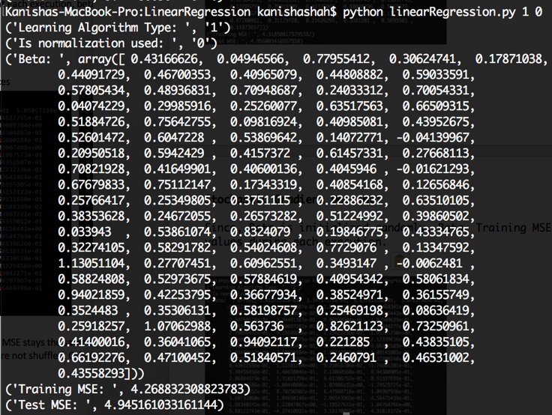

**Stochastic Gradient Descent:**

Since, Beta is initialized randomly, Beta, Training MSE, and Test MSE has different values during each execution.

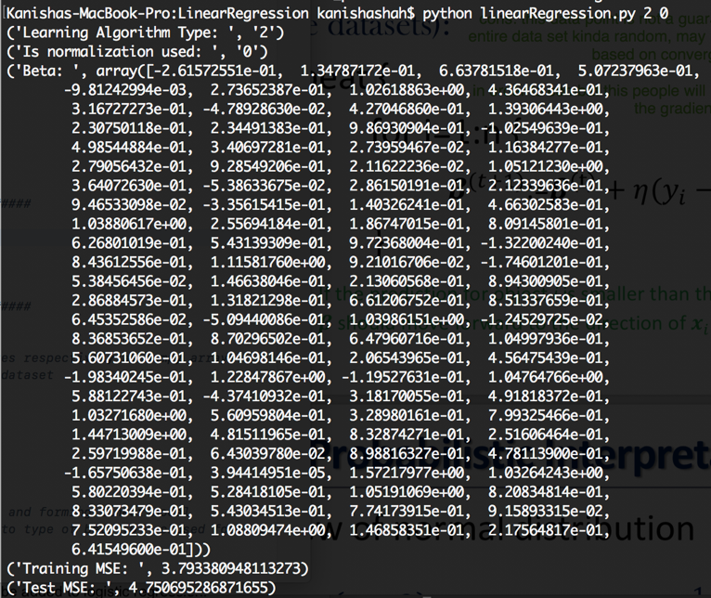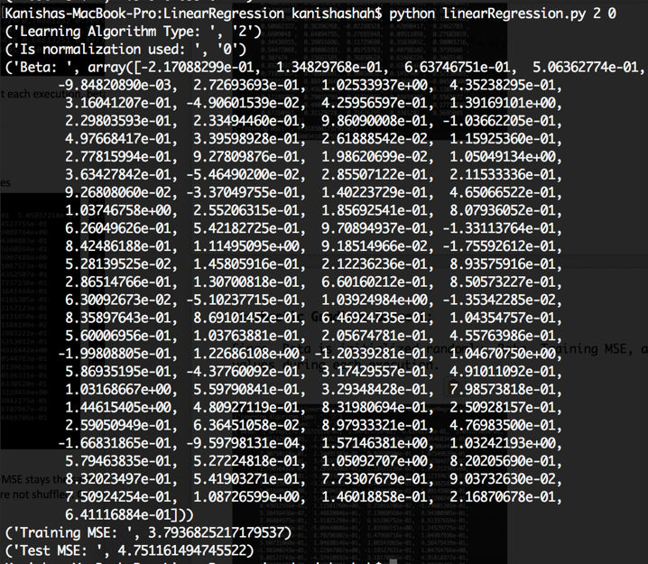

The mean square error and learned weights for the test data set in each version is not same but there is not much difference. MSE in increasing order is given by Closed Form solution, stochastic gradient descent, and batch gradient descent. Closed form minimizes the cost function such that it gives us the same weights and MSE for each execution. But, closed form would prove to be very expensive if our data set was larger as we would have to compute inverse. Batch and Stochastic have an incremental approach. Batch computes the whole data set for one update. Stochastic approximates for one update which makes computation faster than stochastic. Our results for stochastic and batch are based on luck since we randomize the initialization.

Part b)

**Closed-Form Solution:**

After normalization, training MSE and test MSE remains same.

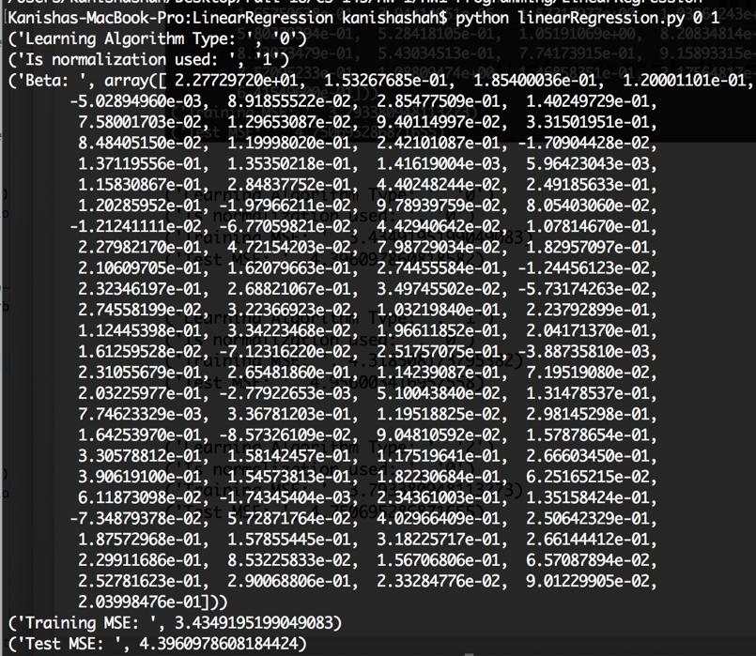

**Batch Gradient Descent:**

After normalization, training MSE and test MSE decreased. It gets closer to the range of closed form.

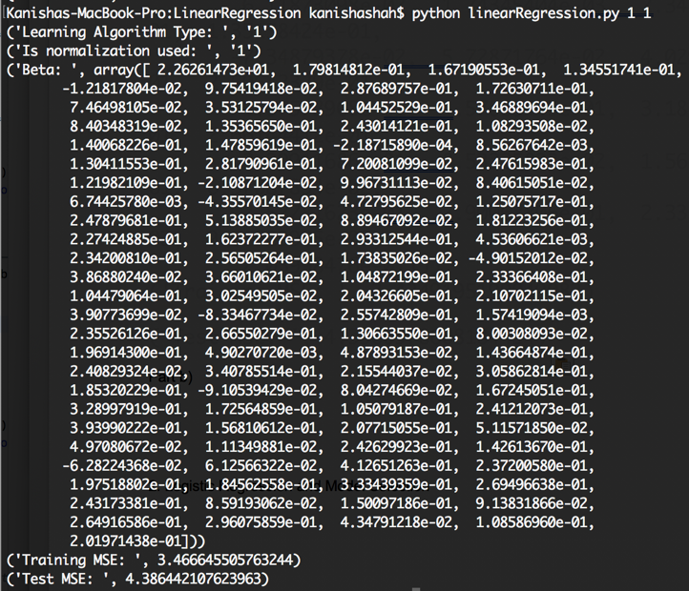

**Stochastic Gradient Descent:**

After normalization, training MSE and test MSE increased.

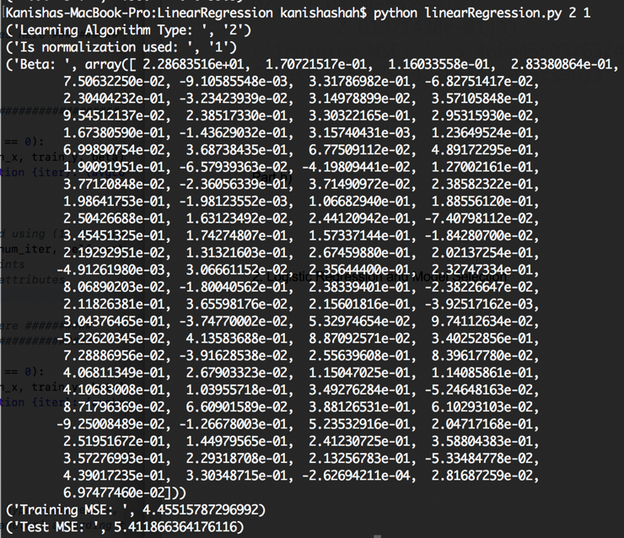

Normalization brings everyone on the same common scale from different scales, so that they can be compared. Normalization does not affect β and MSE for closed-form solution. It makes a little difference for Batch gradient descent and stochastic gradient descent. Training and test MSE got better for batch but got worse for stochastic. Stochastic converges faster and do not get enough iterations to update weights. So, the accuracy of stochastic decreases. Batch iterates more to give more accurate results. There was no gain by normalizing data for closed form.

1. Logistic Regression and Model Selection

Part a)

**Batch Gradient Descent:**

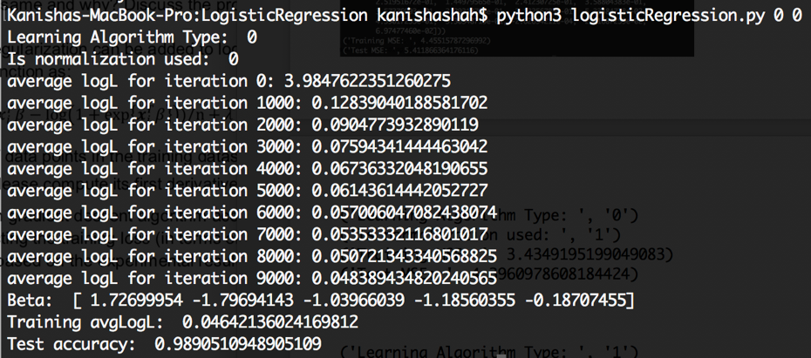

Normalized:

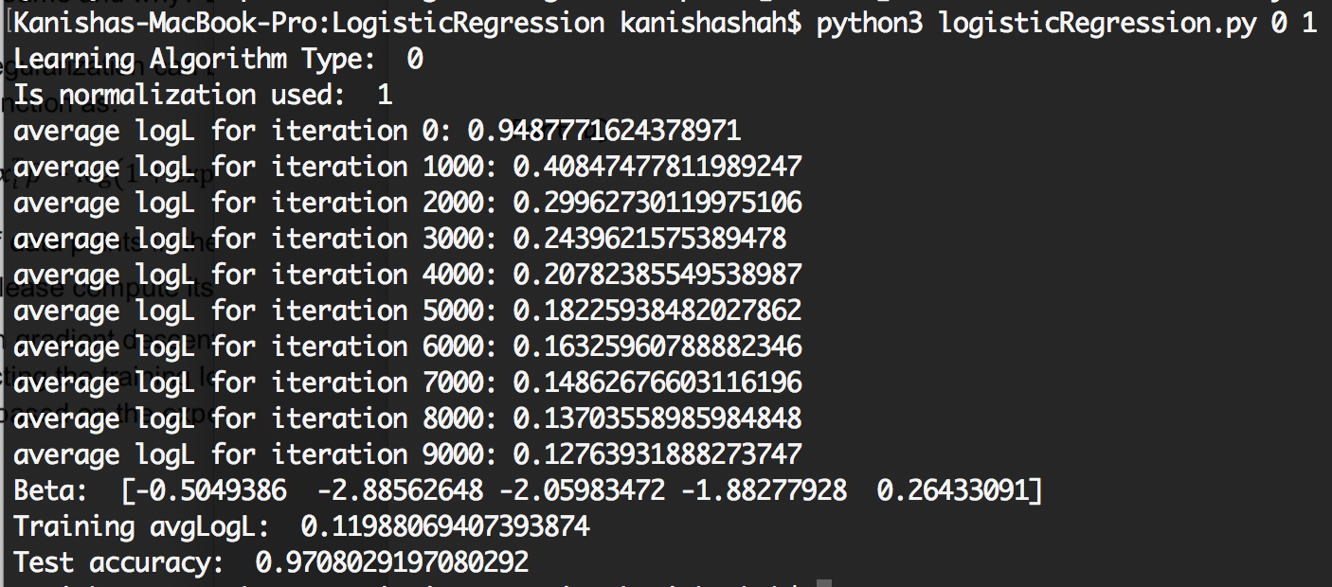

**Newton Raphson Method:**

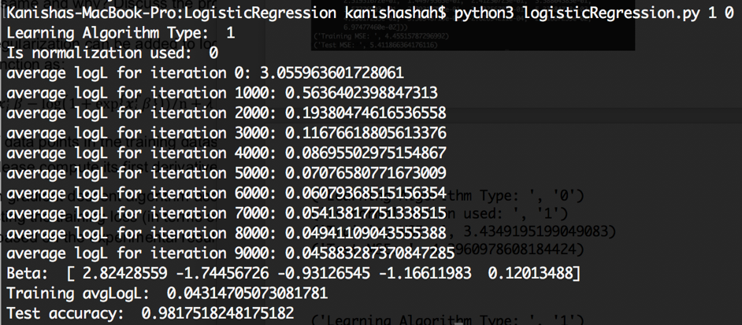

Normalized:

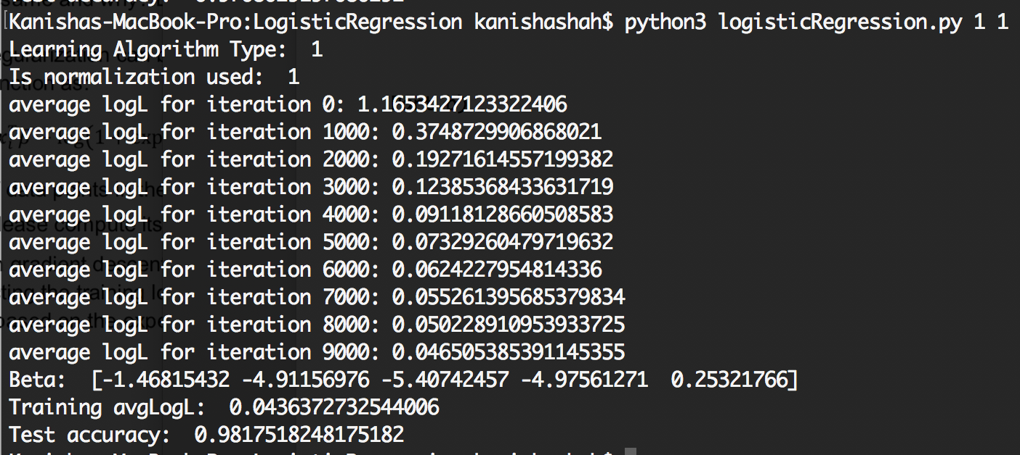

Batch gradient descent is more slightly more accurate than Newton Raphson.

Newton requires us to take derivative twice which can increase complexity. Batch gradient only requires one. Batch converges better. The weights for both the methods do not differ much. Thus, Batch gradient is much simpler.

Part b)

To implement this, we can add 2 ∗ x ∗ 𝛽 to the first derivative of log likelihood. We can test on different values of x.

By experimenting (x = 0.1, 0.25, 0.01, 100, 25), we can see that this does not improve accuracy. The higher value of x deceases accuracy. Regularized data does not fit this data set. Bias only decreases our accuracy.